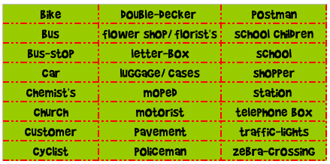
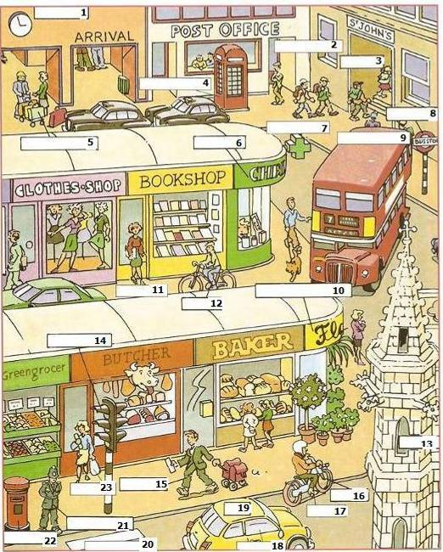
- Look at this town! Use the words in the boxes to fill in the gaps.
- Answer these questions: IN THIS TOWN…. WHERE CAN YOU….?

  - Where can you buy aspirins?
  - Where can you pray?
  - Where can you buy some flowers?
  - Where can you post letters?
  - Where can you learn and study?
  - Where can you cross the street?
  - Where can you get fruit and vegetables?
  - And meat?
  - What about bread?
  - Where can you get a bus?
  - Where can you buy a dress?


- Write T if the sentence is true or F if it is false. (Correct the false ones)

- There is a bookshop between the clothes shop and the chemist’s. (…..)
- There are plants outside the florist’s. (…..)
- There’s a letterbox in front of the bookshop. (…..)
- There is a greengrocer next to the post office. (…..)
- It’s nearly three o’clock. (…..)
- The postman is carrying four envelopes in his hand. (…..)
- The double-decker bus is yellow.. (…..)
- There is a couple waiting for the taxis. (…..)
- The telephone box is near the school. (…..)

- IS THERE…? / ARE THERE…? (Give answers as regards this town)

- Is there a letterbox near the school?
- Is there a bus stop near the school?
- Are there people in the post office?
- Are there cars in the street?
- Is there a cinema in this town?
- Is there a butcher next to the baker?
- Are there any vegetables outside the greengrocer?
- Is there a station?
- Is there a cyclist riding a bike?
- Is there a man walking a black dog?




- You can work on some prepositions
NEAR/ NEXT TO BEHIND BETWEEN
IN FRONT OF OVER IN ON UNDER

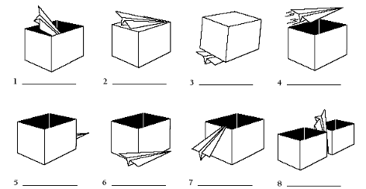

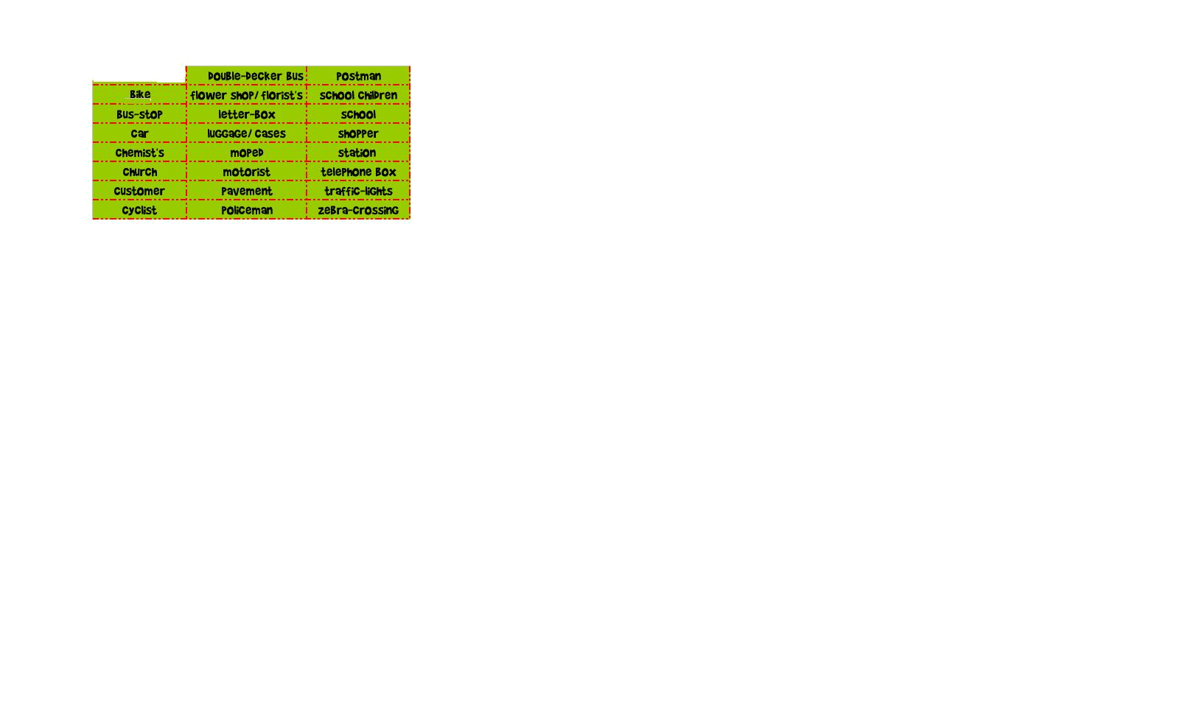
May be this can help you too!!!
9 15
12 10 3

8 22 2
19 5 11
6 16 1
13 17 4
18 7 14
12 21 20

You could use DRIVER (18) instead of CUSTOMER.

